**NAME: ALI GHULAM MURTAZA**

**ROLL NO: SFI-24S-001**

**LAB NO: 6**

**TASK NO 1: Write a while loop that prints numbers from 10 down to 1.**

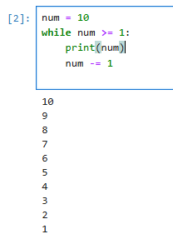

**TASK NO 2: Create a program that uses a for loop to iterate over a string and count the number of vowels.**

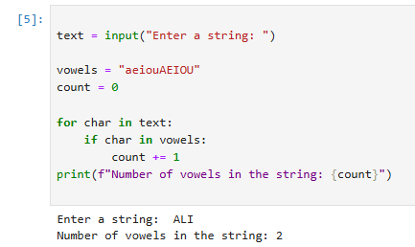

**TASK NO 3 :Write a program that prints the Fibonacci series up to n terms using a while loop**

